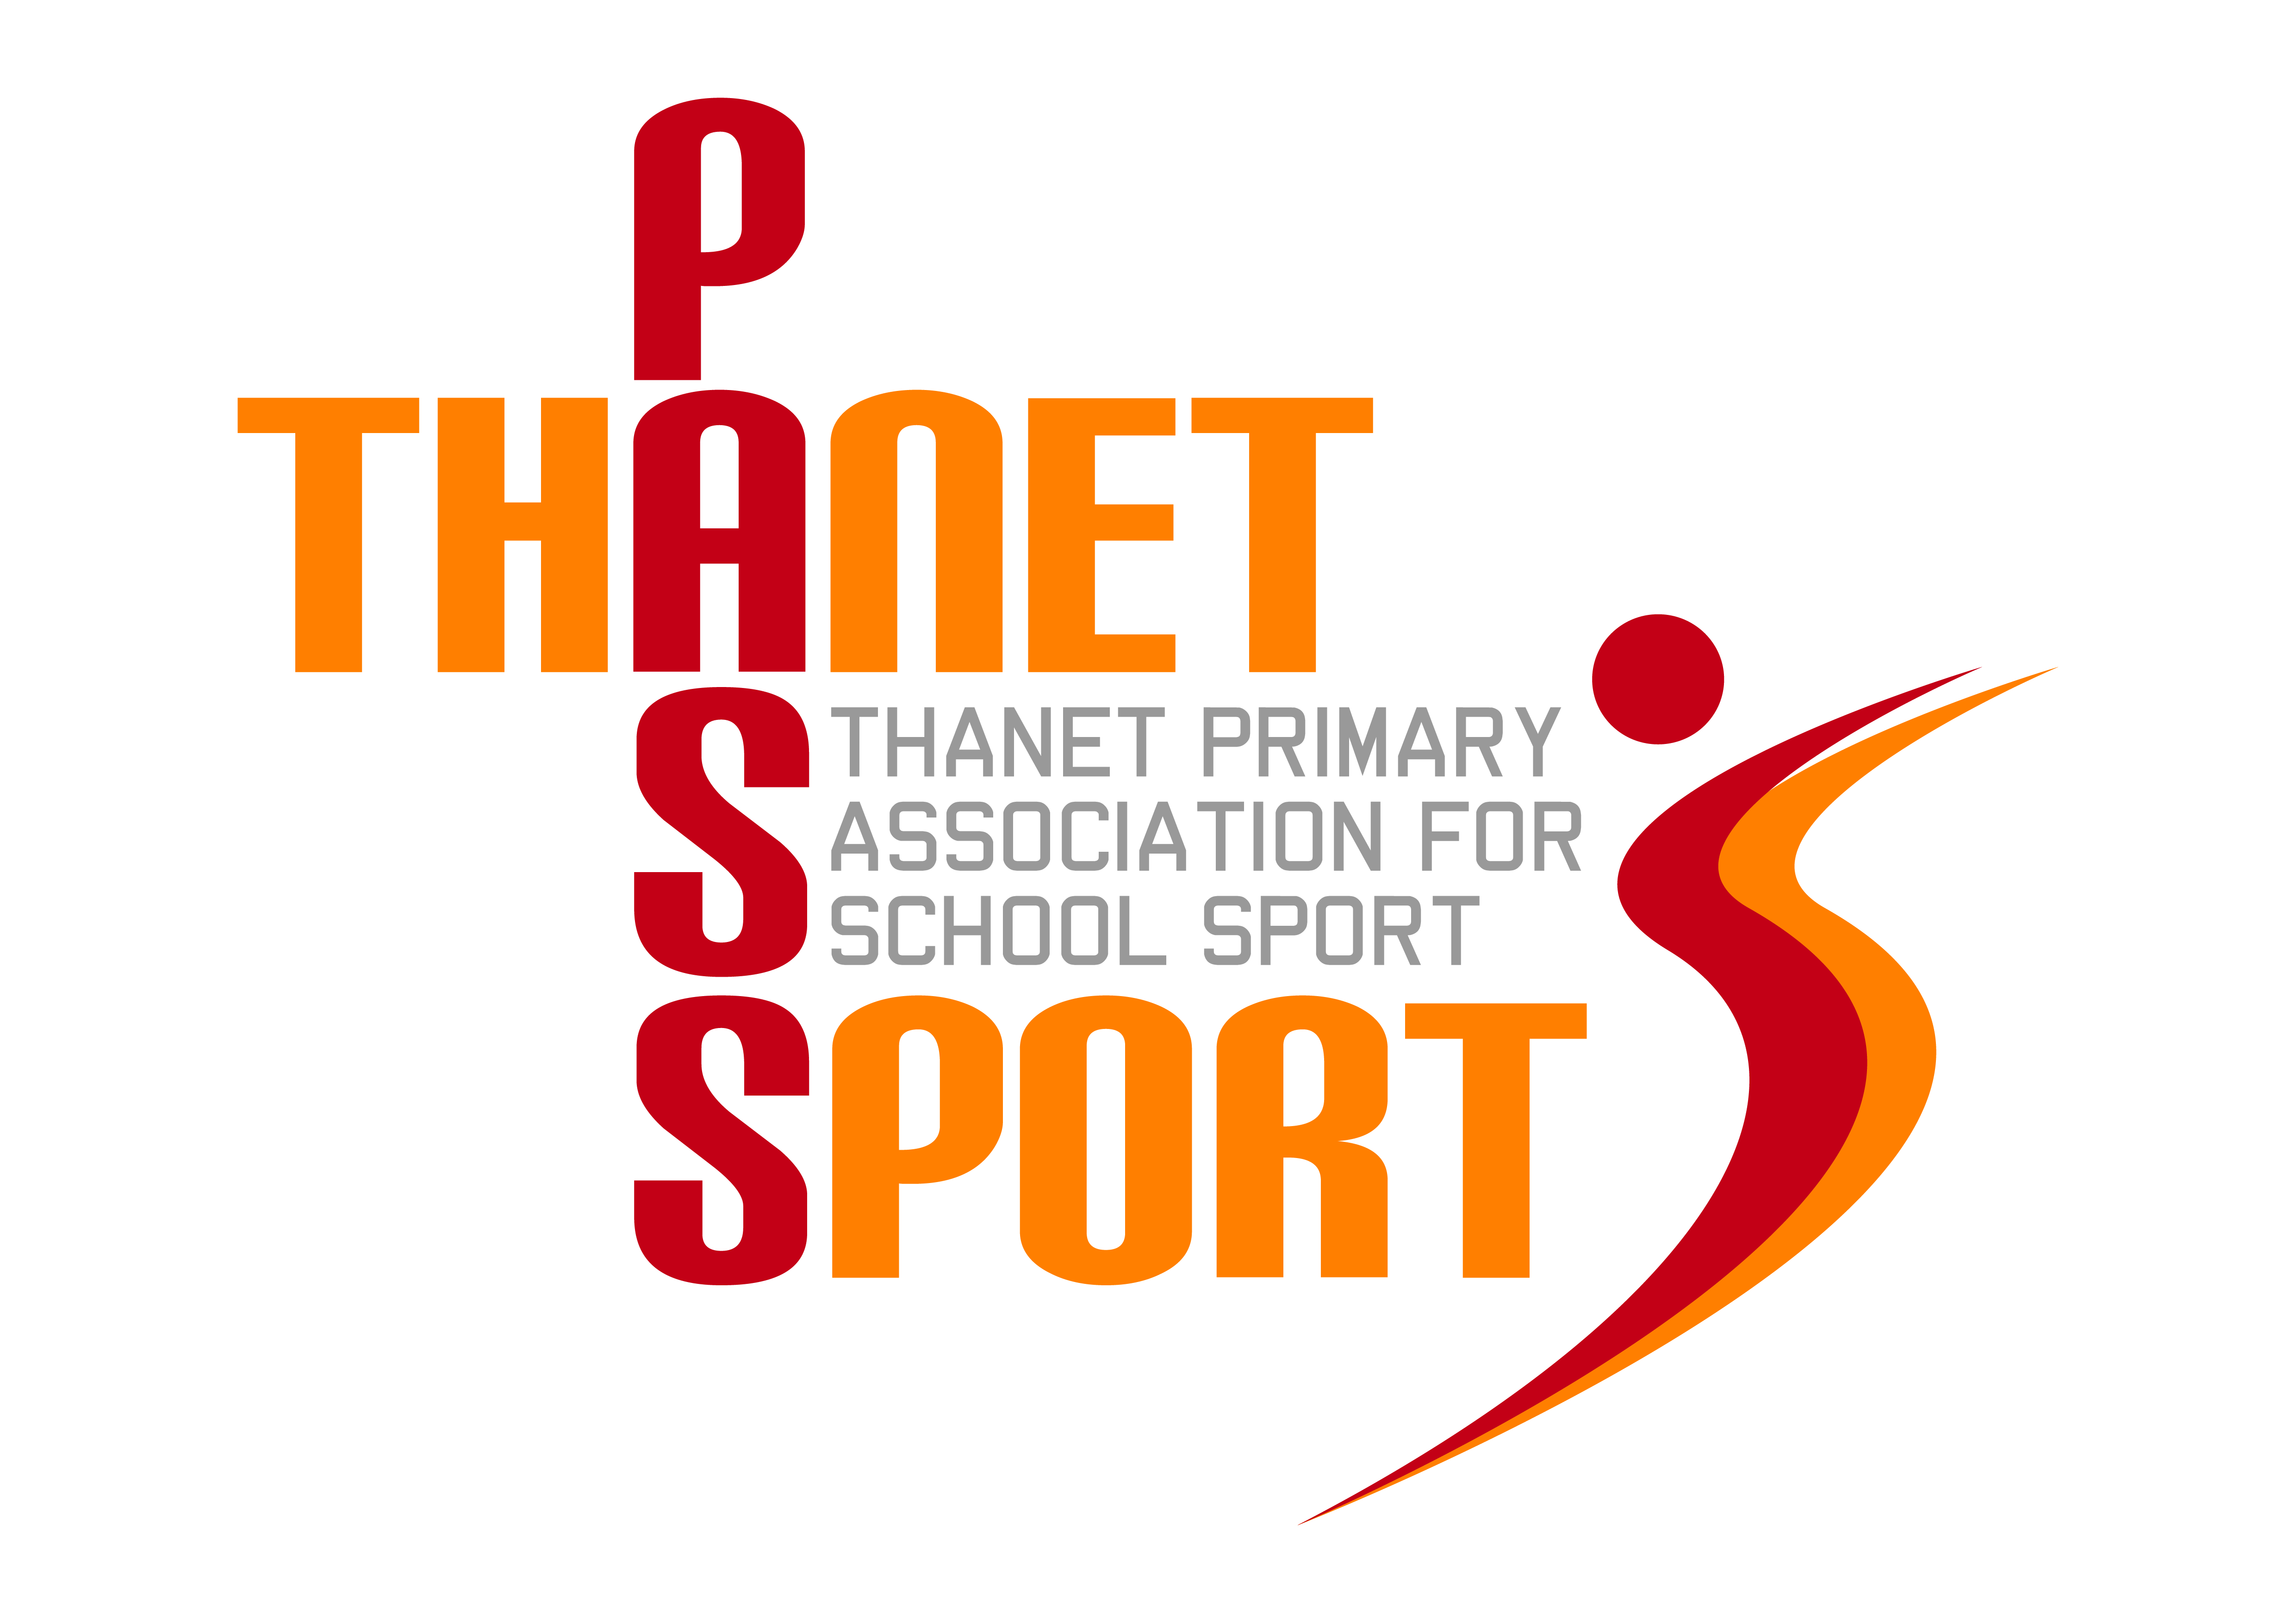
THANET PASSPORT
POST-LOCKDOWN QUESTIONNAIRE
April 2021
Assuming the Government’s ‘road map’ runs as expected, we have put together an extensive programme of extra-curricular events for Term 6 and we are also planning to have the usual full calendar of events for 2021/22. In order to help these run smoothly and with maximum participation, please complete the Questionnaire below and return it to garybcrees@gmail.com as soon as possible.
Name of School:
Name of Headteacher:
Address of School:
Phone number of School:
Main Passport Contact & e-mail address:
Mobile number (for emergency use only):W
Other Contact(s) at School & e-mail address(es):
Is your Headteacher likely to allow your school to participate in any Passport events in Term 6?
All events before 21st June are in school time and outdoors. NGB guidance will be followed where appropriate, eg use of equipment. Assuming you attend an event, what are your school’s policies and expectations regarding the following?
- Masks –
- Sanitisers –
- Testing -
- Transport –
- Use of toilets –
- External providers, e.g. umpires –
- First Aid -
- Other -
We do not think parents should be attending events in Term 6, even after 21st June. Do you agree and is this practical for you?

