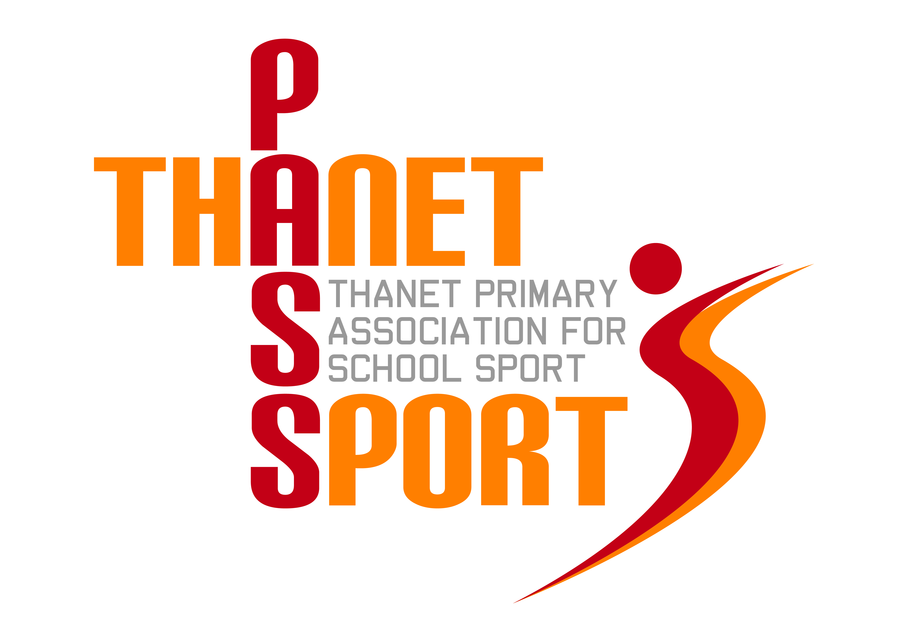
Thanet Primary Association for School Sport

(PasSport)

Annual Report 2014/15
Thanet Passport Committee
Gary Rees (Chairman & Administrator), Lisa Sparkes, Mo Lupton, Tony Bailey, Sue Mileham, Tracey Jones, Scott Tift, Simon Hillier
The Year in Review
Thanet Passport is about to enter its fifth year and we are both pleased and surprised at how far we have come in such a short space of time. This is due to a combination of factors, not least the hard work and dedication of PE teachers, sports coaches and the Passport Committee. Our unique strength is based on the fact that every primary school in the District is a member, fully supported by a host of local sports associations and clubs. We are now beginning to attract sponsorship, both financial and in kind, which not only means that the future of our organisation is secure, but it also allows us to improve the quality of the service we provide to our member schools.
I have now taken on the role of Administrator, a part-time position, although at times it seems like a full-time job! One of my tasks has been to seek out sponsorship and this year our major partners are Ursuline College, Thanet District Council, Margate Football Club and the School News Group, with additional sponsorship from Baypoint, Ramsgate Trophies and Your Leisure. In addition we were successful in obtaining a £2000 grant from The Gibbons Family Trust. In September East Kent College will be added to the list and we hope that we will continue to enjoy the support of all our existing sponsors whilst attracting new ones in the future.
One of the benefits of this extra revenue is that we have been able to continue our policy of providing participation medals for most of our events. We have found that the prospect of receiving a medal is very motivating for the children and we have received reports of children wanting to take part in more and more sports so that they can add to their medal collections. As a result of sponsorship this year we have been able to provide every school with a plaque for their entrance hall and all PE teachers and coaches have received a polo shirt. We have also been able to introduce our much coveted ‘VIP’ (Volunteer In Passport) enamel badges which are given out as a small token of appreciation to everyone who helps run school sport, from organisers to mini-bus drivers! Over 250 young sports leaders from local secondary schools have also received these badges for their invaluable help at many of our events.
The cost of Basic Passport to schools still remains at £300 for juniors and through primaries and £100 for infants and small schools, which represents fantastic value for money. Next year we plan to give schools extra equipment, such as hockey sticks and kwik cricket balls, as a reward for taking part in certain designated events.
Our website, www.thanetpassport.org is now up and running and includes regular updates, reports and sport specific guidance. We can also be found on Twitter, @pas_sport and reports of our events feature regularly in the Isle of Thanet Gazette.
A highlight of the year for all of us was our ‘Unsung Hero’ Award at the Thanet Sports Awards held at Margate Winter Gardens last November. It was very gratifying to have our work recognised, especially as this year we have gone on to break all records. Our participation figures have increased to 8400, involving over 4000 children. That means that a third of all primary aged children in Thanet have represented their school in at least one of the 60 sports events we have supported and organised this year. New events have been added this year, such as our fantastic Dance competition, bringing the total number of sports on offer to 21, with the proposed addition of table tennis and archery next year.
This year has been an East Kent School Games year and the winners of many of our competitions went on to represent the Thanet District with pride. These included the following:
Football – Chilton, Haddon Dene and Upton
Speed Stacking – Chilton & St Peter’s
Basketball – St Peter’s
Sports Hall Athletics – St Saviour’s & Upton
Tri-Golf – Northdown
Handball – St Peter’s
Hockey – Upton & St Gregory’s
Netball – St Peter’s
Squash – Christ Church
Infant Agility – Palm Bay
Tennis – Palm Bay
Rugby – Christchurch, Upton & St Nicholas-at-Wade
Gymnastics – Garlinge, Callis Grange, Bromstone and Upton
Cricket – Christchurch & Bromstone

Super Passport continues to offer high quality local training and support for member schools, as well as discounts on membership of sports organisations and local services. Their local mini-conference was well attended and will be repeated next year. Termly PE co-ordinator meetings have been well attended and schools that have had Ofsted inspections have all reported that membership of Basic and Super Passport has ticked all the inspectors’ boxes.
Finally, Thanet Passport continues to be very grateful for the continued support of The Ursuline College, providing us with expertise, use of their facilities and administrating our finances. I would like to thank Suzanne Gough, all the members of the Passport Committee and all of the event organisers whose commitment and dedication needs to be recognised and commended.
Financial Review
Financial Year 2014/15
Income | £ |  | Expenditure | £
Rollover 13/14 | 4337 |  | Administration | 5000
Schools | 8400 |  | Coaching | 573
Sponsorship | 9250 |  | Stationery & photocopying | 328
Other | 129 |  | Trophies, medals & certificates | 5196
 |  |  | Ambulance & first aid | 500
Total | 22166 |  | Total | 12597
 |  |  | Balance (rollover 15/16) | 9569

Thank you for your continued support as we look forward to a fifth successful year.
Gary Rees
Chairman of Thanet Primary Association for School Sport

