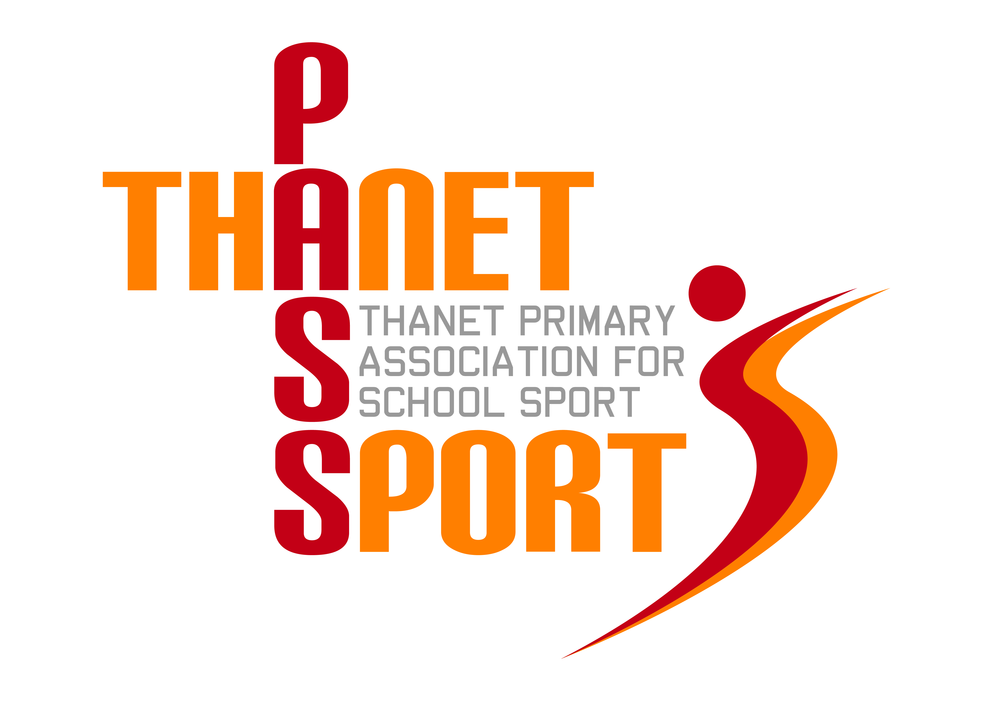
Thanet Primary Association for School Sport

(PasSport)

Annual Report 2015/16
Thanet Passport Committee
Gary Rees (Chairman & Administrator), Lisa Sparkes, Mo Lupton, Tony Bailey, Sue Mileham, Tracey Jones, Scott Tift, Gwyn Hughes
The Year in Review
A key measure of our success has always been the number of children who take part in our events. When Thanet Passport first started there were 48 events covering just 12 different sports, involving about 2000 children. This has now doubled to over 4000 children, meaning that roughly a third of all primary aged children in Thanet have represented their school in at least one of the 66 sports events we have supported and organised this year. For the fifth year running our participation figures have increased - this time by a further 1000 to 9476. New events have been added this year, such as Badminton and American Football, bringing the total number of sports on offer to 23, with the proposed addition of hoola-hooping next year!
With increased participation we have seen increased levels of success at County level, with several of our schools gaining medals at the Kent School Games. It was also good to see so many different schools enjoying victory in our various competitions. These included:-
Football – St Saviour’s, Haddon Dene, St Ethelbert’s, Christ Church, Minster, Draper’s Mills, Salmestone, Cliftonville, Garlinge, Palm Bay and Upton
Speed Stacking – Chilton
Basketball – St Peter’s
Sports Hall Athletics – St Saviour’s
Dodgeball - Bromstone
Tri-Golf – Salmestone
Handball – Upton
Dance – Christ Church
Hockey – Upton & Salmestone
Netball – St Peter’s, Christ Church, St Laurence & Upton
Squash – Christ Church
Infant Agility – Callis Grange
Tennis – Dame Janet & Chilton
Swimming – Haddon Dene & Upton
Rugby Union – Christ Church, St Peter’s, Upton, St Joseph’s & Northdown
Rugby League – Minster
Gymnastics – St Mildred’s, Callis Grange and Bromstone
Cricket – Northdown & Minster
Quad Kids – St Joseph’s
American Football - Newlands
Fair Play – Minster, Northdown & Salmestone

We have featured heavily in the local press this year, almost on a weekly basis. Our website, www.thanetpassport.org.uk, has been completely revamped, and includes regular updates, reports, lots of photos and sport specific guidance. This guidance includes our Pre-entry Protocol to which we will be adding a teacher checklist and ‘Passport Charter’ that can be given to parents and children, thereby hopefully preventing late withdrawal from events, which has caused no little disruption this year.
Schools that attended the Dodgeball this year all received a free set of balls and Passport also paid for Tri-Golf equipment and kits for both the Girls and Boys District football teams. Usefully, we also purchased ‘Not to be Photographed’ wristbands which are available to all schools at every one of our events. The local press have told us that it makes their lives much easier – provided they take notice of who is wearing them! Another initiative has been the ‘Margate Mascot Matchday Experience’ which we developed in partnership with Margate FC. 8 schools took advantage of this last season and a great time was had by all the children who attended with their parents. This initiative will continue next season.

It may be a sign of the times, but sadly the level of sponsorship we receive has dropped significantly. Therefore the Committee decided at its AGM that Passport should move towards being self-financing. Up to now we have relied heavily on sponsorship to balance the books but this is no longer sustainable. We believe that any sponsorship should be used to pay for the extras, such as free equipment for schools, not to subsidise the schools’ membership. Over the past 5 years the number of events and participation figures have increased significantly, as has the administration time, yet the comparatively small affiliation fee of £300 per school (or £100 for infants and small schools) has remained the same. Therefore the affiliation fee will rise to £450 next year and £600 the year after (£150 and then £200 for infant and small schools). At this point Passport will be self-sufficient, as we do not think we can offer much more given the already crowded calendar. With the Sports Premium guaranteed until 2020 and worth on average £10K p.a. to most schools, plus the advent of the so-called ‘sugar tax’, we believe that our affiliation fee offers excellent value for money, particularly as many other districts pay profit making firms far more for much less in comparison. Sadly, gone are the days when teachers used to sit on various committees and organise a few extra-curricular sports in their spare time (was there ever such a thing as ‘spare time?), but happily in Passport we have an outstanding model that is not only being promoted in Kent, but around the country.
Finally, Thanet Passport continues to be very grateful for the continued support of The Ursuline College, providing us with expertise, use of their facilities and administrating our finances. It is with sadness that we say goodbye to Suzanne Gough, the SGO at The Ursuline, who is moving on to pastures new. This does give rise to some uncertainty, particularly around the future of Super Passport, which once again has provided high quality local training and support for member schools. On a personal note I would like to thank Suzanne for all she has done in Thanet, as well as the members of the Passport Committee and all of the sports teachers, coaches and event organisers whose commitment and dedication needs to be recognised and commended.
Financial Review
Financial Year 2015/16
Income | £ |  | Expenditure | £
Rollover 14/15 | 9569 |  | Administration | 10000
Schools | 8750 |  | Equipment & Kit | 698
Sponsorship | 2442 |  | Coaching | 1113
Other | 125 |  | Trophies, medals & certificates | 5262
 |  |  | Ambulance & first aid | 550
Total | 20886 |  | Total | 17623
 |  |  | Balance (rollover 15/16) | 3263

Thank you for your continued support as we look forward to a sixth successful year.
Gary Rees
Chairman of Thanet Primary Association for School Sport

