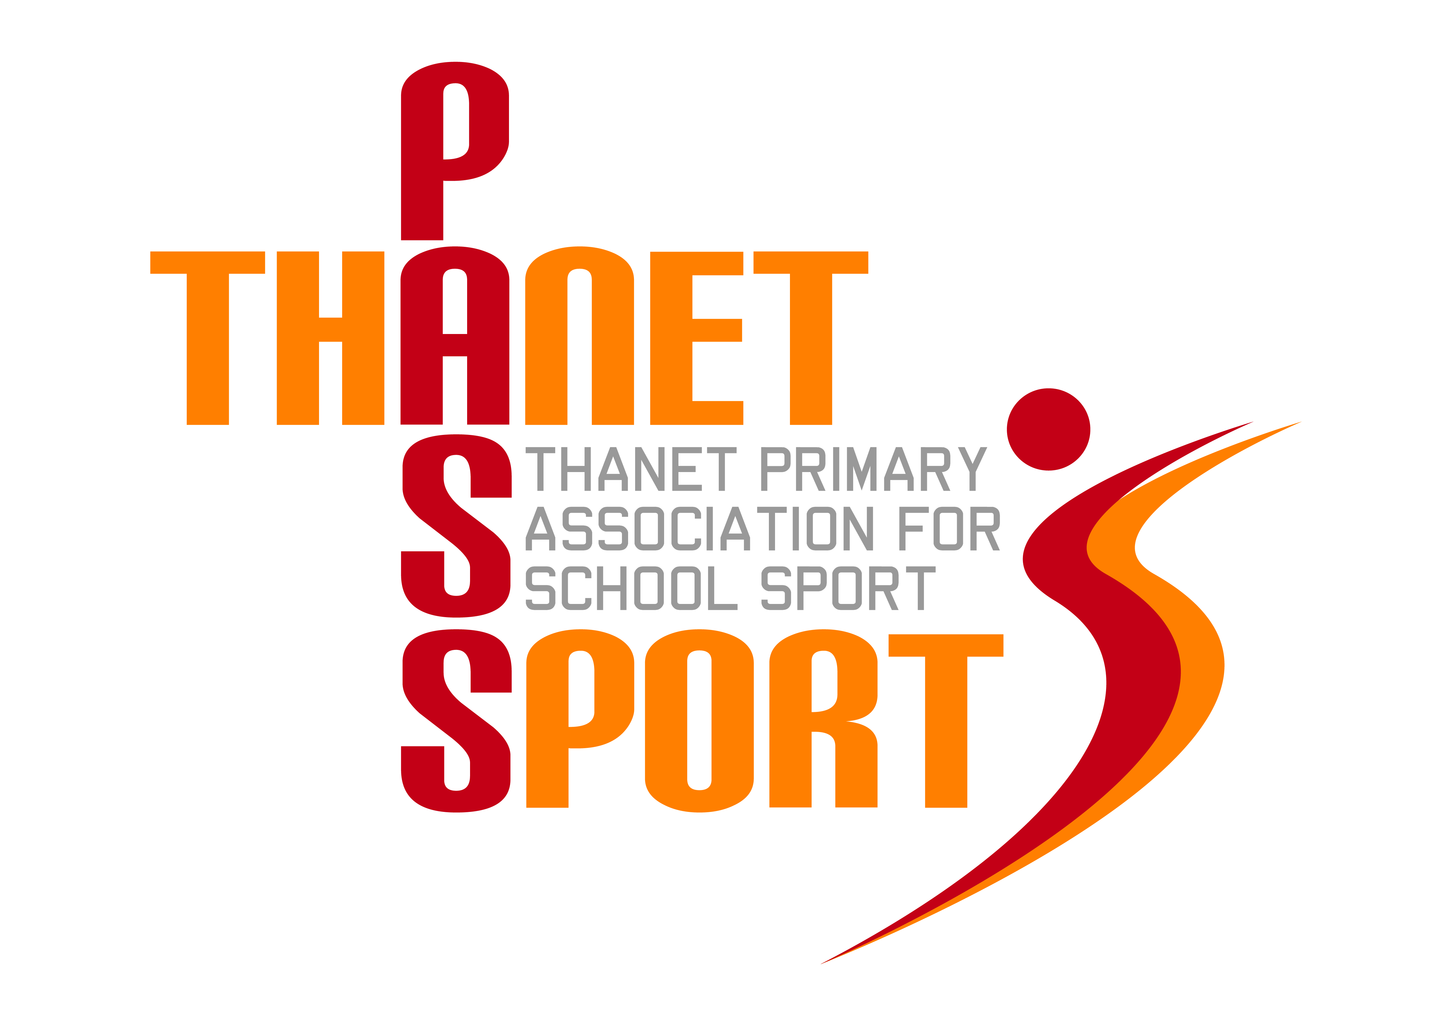
Thanet Primary Association for School Sport

(PasSport)

Annual Report 2021/22
Thanet Passport Committee
Gary Rees (Chairman & Administrator), Scott Tift (Vice Chair), Lisa Sparkes, Jack Hearn, Jade Bailey, Tony Bailey, Katie Delderfield, Steve Holmes, James Hood, Stephanie Selsby (School Games Organiser)
The Year in Review
Having exceeded participation figures of 10,000 in 2018/19, sadly we then came down to earth with a heavy bump, along with the rest of the country, due to the impact of the coronavirus pandemic. All face-to-face events ceased in March 2020 and we did not resume until June 2021. As with many other activities, this meant that that whole cohort of children missed out on the opportunity to represent their schools at sport and, even when we resumed, many schools were understandably reluctant to interact with other schools at that point.

Consequently there seemed little point in publishing Annual Reports for 2019/20 and 2020/21. However the accounts for those years are included with this report. Happily, all member schools bar one chose to maintain their Passport membership, knowing that this would ensure that our organisation would be in a position to continue its work once the crisis had passed - and so it has proved.

During lockdown Thanet Passport did what it could to help keep our children fit and to support our schools. Working alongside Stephanie Selsby, our SGO, we organised a number of ‘virtual’ competitions that children and their families could take part in, such as the Home Skills and the MultiFit challenges. Once the children were back in school we ran events such as speed stacking and cross country, whereby schools sent in their results and we then dropped off medals to the winning schools. As many did, we also held Zoom Meetings to support PE staff during that difficult time.

This past year has seen a gradual return to normality, although there are still a good number of schools that have not entered any events. We trust that with our help and support we will be able to return to full participation in 2022/23. Even so, the participation figures were still pleasing, with 6,777 children taking part in the 69 events we were able to run. We also held several networking meetings for PE staff, which were well attended.

The Passport affiliation fees have remained static for the past 5 years, but like everything else costs have increased and therefore for 2022/23 the Committee have decided that the fees will need to rise to £750 for Primary and Junior schools; and £250 for Infant and Small schools. We are a non-profit making organisation run by schools, for schools and this increase means that we will remain self-sufficient. It still represents incredible value for money, particularly as many other districts pay profit making firms far more for much less in comparison, and of course it remains eligible expenditure from the School Sports Premium, not to mention ticking that box for Ofsted.

Next year we will be welcoming Thanet Wanderers as one of our valued partners. They join Ramsgate FC and Margate FC, Broadstairs College, Baypoint Club, Your Leisure, Broadbiz, Total Sports Coaching and Ramsgate Trophies, all of which are local clubs and businesses who support our work. In return we hope that all schools will support these businesses where possible.

Enjoyment and participation lie at the heart of what we do and the provision of medals at most of our events remains one of Passport’s hallmarks. However, sport by its very nature is also competitive and many different schools have enjoyed victory in our various competitions. These included:-
Football – St Gregory’s, Holy Trinity Ramsgate, St Saviour’s, Upton, St George’s, Minster, Bromstone, Garlinge, St Ethelbert’s & Chilton
Speed Stacking – Minster, St George’s & Priory
Basketball – St Peter’s
Sports Hall Athletics – St Saviour’s & Holy Trinity Ramsgate
Dodgeball – St Joseph’s & Haddon Dene
Table Tennis – Chilton
Handball – Garlinge
Badminton – Chilton
Hockey – Holy Trinity Ramsgate
Netball – St Peter’s & Garlinge
Squash – Holy Trinity Ramsgate
Infant Agility – Garlinge
Tennis – Holy Trinity Ramsgate & Holy Trinity Margate
Orienteering – Holy Trinity Margate
Rugby Union – Chilton, Upton, St Saviour’s, Palm Bay, Holy Trinity Ramsgate & Holy Trinity Margate
Rugby League – Minster
Rapid Fire Cricket – Garlinge
Cricket – Upton & Holy Trinity Ramsgate
Quad Kids – St Mildred’s
Fair Play – Garlinge, St Saviour’s, Upton & Cliftonville

Thanet Passport continues to be very grateful for the continued support of The Ursuline College and Stephanie Selsby, our SGO, for providing us with expertise, use of facilities and administration of our finances. In addition we must thank all of our host schools, both primary and secondary, as well as the sports teachers, coaches and event organisers, not forgetting the Passport Committee, who should all be commended for their commitment and dedication. Finally, thank you to all our member schools for your continued support as we look forward to a twelfth successful year.
Gary Rees
Chairman of Thanet Primary Association for School Sport

Financial Review
Academic Year 2019/20
Income | £ |  | Expenditure | £
Rollover from 18/19 | 3784 |  | Administration | 12500
Schools | 17800 |  | Coaching | 763
Sponsorship | 500 |  | Trophies, medals & certificates | 4646
 |  |  | Ambulance & first aid | 800
 |  |  | Calendars | 165
Total | 22084 |  | Total | 18874
 |  |  | Balance (rollover to 20/21) | 3210

Academic Year 2020/21
Income | £ |  | Expenditure | £
Rollover from 19/20 | 3210 |  | Administration | 12500
Schools | 17290 |  | Coaching | 700
Sponsorship | 500 |  | Trophies, medals & certificates | 1505
 |  |  | Equipment | 130
Total | 21000 |  | Total | 14835
 |  |  | Balance (rollover to 21/22) | 6165

Academic Year 2021/22
Income | £ |  | Expenditure | £
Rollover from 20/21 | 6165 |  | Administration | 14613
Schools | 17800 |  | Coaching | 1175
Super Passport | 2381 |  | Trophies, medals & certificates | 5122
 |  |  | Ambulance & first aid | 800
 |  |  | Calendars | 148
 |  |  | Equipment | 363
Total | 26346 |  | Total | 22221
 |  |  | Balance (rollover 22/23) | 4125

