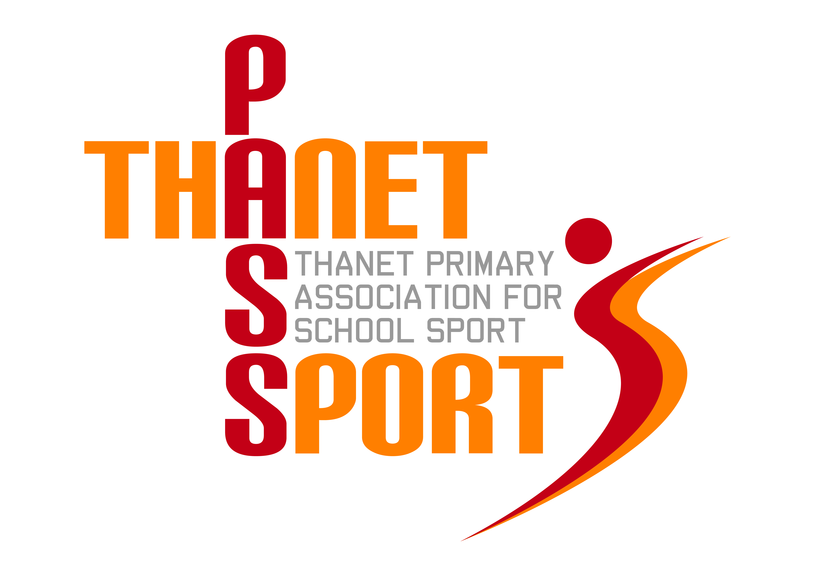
Thanet Primary Association for School Sport

(PasSport)

Annual Report 2013/14
Thanet Passport Committee
Gary Rees (Chairman), Lisa Sparkes, Mo Lupton, Tony Bailey, Sue Mileham, Tracey Jones, Scott Tift, Simon Hillier
The Year in Review
As we reach the end of our third year we believe we can now say that Thanet Passport is here to stay. Schools have reported high levels of satisfaction with our work and talking with sports people who have a national perspective it appears that we have a rather unique set up in Thanet which is much admired. This is due, I think, not only because every primary school in the District is a member and nearly all of the local sports associations have supported the initiative, but also because of the dedication shown by the teachers and sports coaches who work in our schools. In particular I would like to thank Suzanne Gough, all the members of the Passport Committee and all of the event organisers whose commitment and dedication needs to be recognised and commended.
We have actually increased our membership this year, as we welcome Laleham Gap and The Foreland School as valuable members of the Passport community. Despite a wet winter, which led to the cancellation of some events, our participation figures have increased to nearly 7000, involving over 2500 children. We held 58 events covering 19 different sports, including new additions such as squash and rugby league. We have also developed links with more local sports clubs, such as Thanet Swim Club. Next year we are planning to add Dance and Archery to our calendar, although we have found that there is a limit to the number of events that schools have the resources (including time and expertise) to enter.
This year has been a Kent School Games year and the winners of many of our competitions went on to represent the Thanet District with pride. These included the following:
Basketball – Palm Bay
Sports Hall Athletics (Years 3/4 & 5/6) – Upton
Tri-Golf – Palm Bay
Hockey – Upton & St Nicholas-at-Wade
Netball – Palm Bay
Squash – Christ Church and Northdown
Infant Agility – Callis Grange
Tennis – St Peter’s
Rugby – Cliftonville, Upton & St Nicholas-at-Wade
Gymnastics – Chilton, Callis Grange, and Upton
Cricket – Palm Bay & Christchurch

A feature of Passport this year has been regular electronic updates for all PE and sports co-ordinators, detailing forthcoming events as well as celebrating achievements. We are also to be found on Twitter @pas_sport, whilst next year we will have our very own website, which we are very excited about. The website is being set up and run by The School News Group who are one of our main sponsors and next year we are hoping to attract even more in the way of sponsorship. This will help secure our future financially and allow us to provide an even better service to schools – especially as the administration burden has grown. The cost of Basic Passport to schools remains at £300 for juniors and through primaries and £100 for infants and small schools, which represents fantastic value for money.
We were very pleased that Margate Ambulance Corps agreed to provide cover at all of our major events, whilst another of our supporters, Thanet District Council, invited us to attend their Sports Awards night at Margate Winter Gardens. We agreed to sponsor the Primary School Award, which deservedly went to Northdown. Next year, depending on how much we raise through sponsorship, we would like to give every school a Passport plaque to put up, as well as recognising the work of all of our helpers with a special enamel badge – a bit like the Olympic Volunteers!
Super Passport has gone from strength to strength this year, offering high quality local training and support for member schools, as well as discounts on membership of sports organisations and local services. Nearly every school has signed up for next year and hopefully we will see more Thanet schools obtaining nationally recognised awards. Termly PE co-ordinator meetings have been well attended and schools that have had Ofsted inspections have all reported that membership of Basic and Super Passport has ticked all the inspectors’ boxes.
Finally, Thanet Passport continues to be very grateful for the continued support of The Ursuline College, providing us with expertise, use of their facilities and administrating our finances.

Financial Review
Financial Year 2013/14
Income | £ |  | Expenditure | £
Rollover 12/13 | 7845 |  | Administration | 5000
Schools | 8305 |  | Venue hire | 810
Sponsorship | 850 |  | Sponsorship | 450
 |  |  | Coaching | 450
 |  |  | Stationery & photocopying | 215
 |  |  | Trophies, medals & certificates | 4354
 |  |  | Clothing & equipment | 884
 |  |  | Ambulance & first aid | 500
Total | 17000 |  | Total | 12663
 |  |  | Balance (rollover 13/14) | 4337

Thank you for your continued support as we look forward to another successful year.

Gary Rees
Chairman of Thanet Primary Association for School Sport

