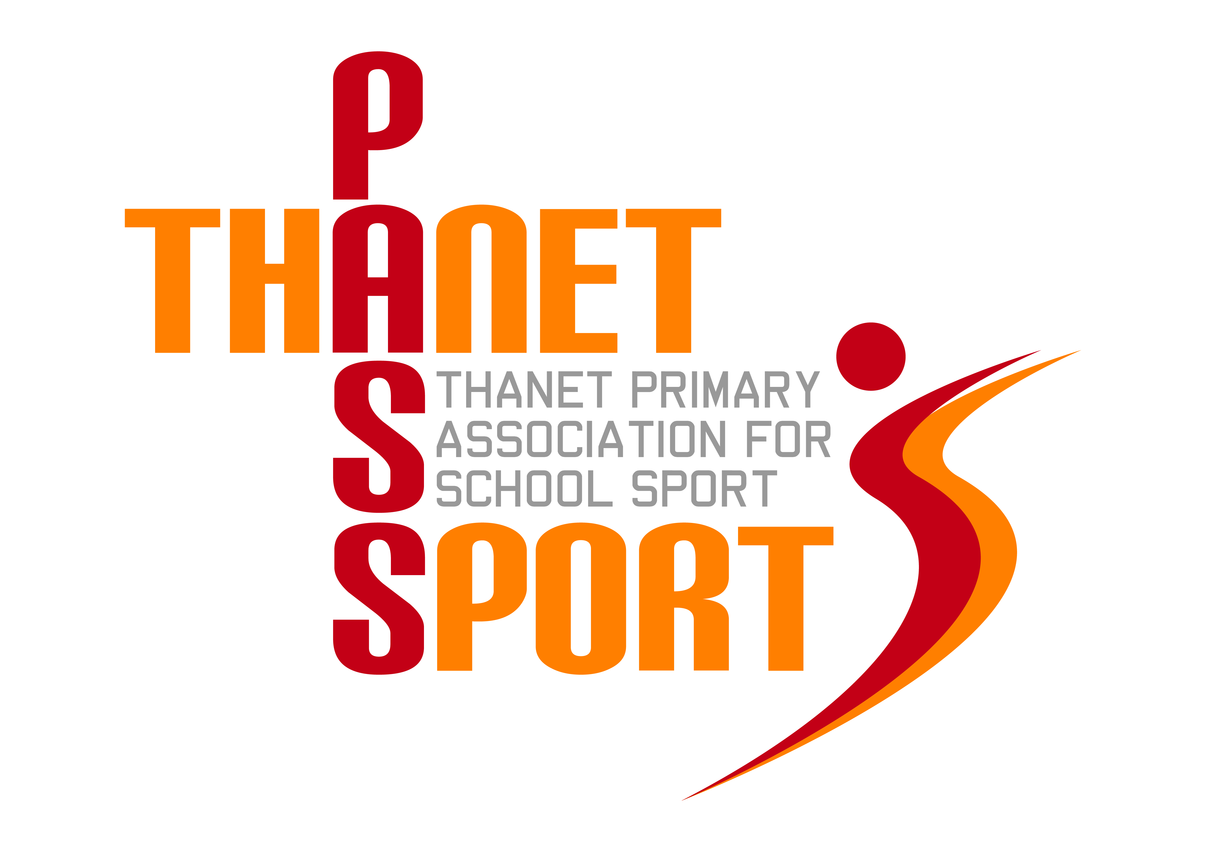
Thanet Primary Association for School Sport

(PasSport)

Annual Report 2016/17
Thanet Passport Committee
Gary Rees (Chairman & Administrator), Lisa Sparkes, Mo Lupton, Tony Bailey, Sue Mileham, Tracey Jones, Scott Tift, Gwyn Hughes
The Year in Review
Thanet Passport continues to go from strength to strength and has an enviable reputation throughout the rest of Kent. This is due to the unique model of inter-school co-operation that we have set up. Once again over 4000 primary aged children have taken part in at least one of the 67 events we have helped organise this year. For the sixth year running our participation figures have increased - this time by a further 400 to 9861. Next year we will be aiming to exceed 10,000! New sports continue to be added, such as Change4Life, Table Tennis and Coola-to-Hoola, bringing the total number of sports on offer to 25, with others in the pipeline.
It was especially pleasing this year to see Thanet Passport receiving positive comments in several local schools’ Ofsted reports, particularly in relation to effective use of the School Sports Premium funding, which is now guaranteed until 2020. Sadly, the ‘Super Passport’ initiative ended this year due to the restricted role of the School Games Organiser at The Ursuline. However, we have tried to fill the gap by organising a series of networking meetings for PE co-ordinators and sports coaches which have proved both popular and useful. As well as chance for schools to share expertise, these sessions have also provided guidance on such things as safeguarding, applying for sports awards and sports specific training – all at no extra cost.

Talking of cost, the affiliation fees for 2017/18 will be £600 for Primary and Junior schools; and £200 for Infant and Small schools. This is eligible expenditure from the School Sports Premium and represents extremely good value for money. We have also been able to access some sponsorship and a grant from the Gibbons Trust which has been used this year to pay for such things as coaching, the purchase of Infant Agility and Sportshall Athletics equipment, as well as kit for our District footballers. Next year the Passport Committee has agreed that any surplus funds should be spent on providing free sports equipment to all schools that enter our events to encourage even greater participation levels.

Once again several of our schools gained medals at the Kent School Games and our reputation for fair play and sportsmanship is something of which we should all be proud. Enjoyment and participation lie at the heart of what we do and the provision of medals at most of our events remains one of Passport’s hallmarks. We have also drawn up a Passport Charter which was sent out to all schools at the start of the year and which is also available on our website. However, sport by its very nature is also competitive and many different schools have enjoyed victory in our various competitions. These included:-
Football – Haddon Dene, Minster, Upton, St Ethelbert’s, Chilton, St Gregory’s, St Laurence, Dame Janet, Cliftonville
Speed Stacking – St Laurence & St Peter’s
Basketball – St Saviour’s
Sports Hall Athletics – St Saviour’s & Upton
Dodgeball - Upton
Table Tennis – St Peter’s
Tri-Golf – Upton
Handball – St Saviour’s
Dance – Palm Bay
Badminton – St Joseph’s
Hockey – Upton
Netball – St Joseph’s, St Saviour’s & Monkton
Squash – Upton
Infant Agility – Bromstone
Tennis – Upton & Chilton
Swimming – St Saviour’s & Upton
Rugby Union – St Saviour’s, St Nicholas-at-Wade, Palm Bay, Dame Janet & Upton
Rugby League – Upton
Gymnastics – Bromstone & St Mildred’s
Cricket – Northdown & Bromstone
Quad Kids – Minster & Callis Grange
Fair Play – Dame Janet, St Saviour’s & Upton

In addition, Thanet Passport itself received a ‘Highly Commended’ trophy at the Thanet Sports Awards in the Community Sport Impact category.
Thanet Passport continues to be very grateful for the continued support of The Ursuline College, providing us with expertise, use of their facilities and administrating our finances. We welcomed a new SGO, Stephanie Howard, at the start of the year and she has now settled in to her role. On a personal note I would like to thank Stephanie and the members of the Passport Committee, plus all of the sports teachers, coaches and event organisers whose commitment and dedication needs to be recognised and commended.
Finally, please feel free to use the Thanet Passport logo on your website or school stationery.

Financial Review
Academic Year 2016/17
Income | £ |  | Expenditure | £
Rollover 15/16 | 1847 |  | Administration | 5000
Schools | 13160 |  | Equipment & Kit | 1943
Grants & Sponsorship | 4400 |  | Coaching | 725
Other | 41 |  | Trophies, medals & certificates | 6491
 |  |  | Ambulance & first aid | 700
Total | 19448 |  | Total | 14859
 |  |  | Balance (rollover 17/18) | 4589

Thank you for your continued support as we look forward to a seventh successful year.
Gary Rees
Chairman of Thanet Primary Association for School Sport

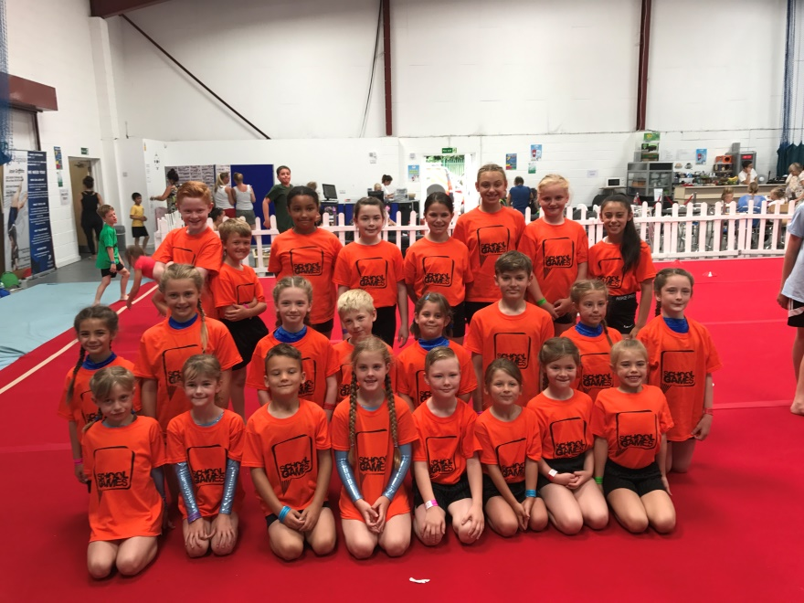
St Joseph’s, Callis Grange, St Mildred’s & Bromstone
representing Thanet at the Kent Gymnastics Finals

