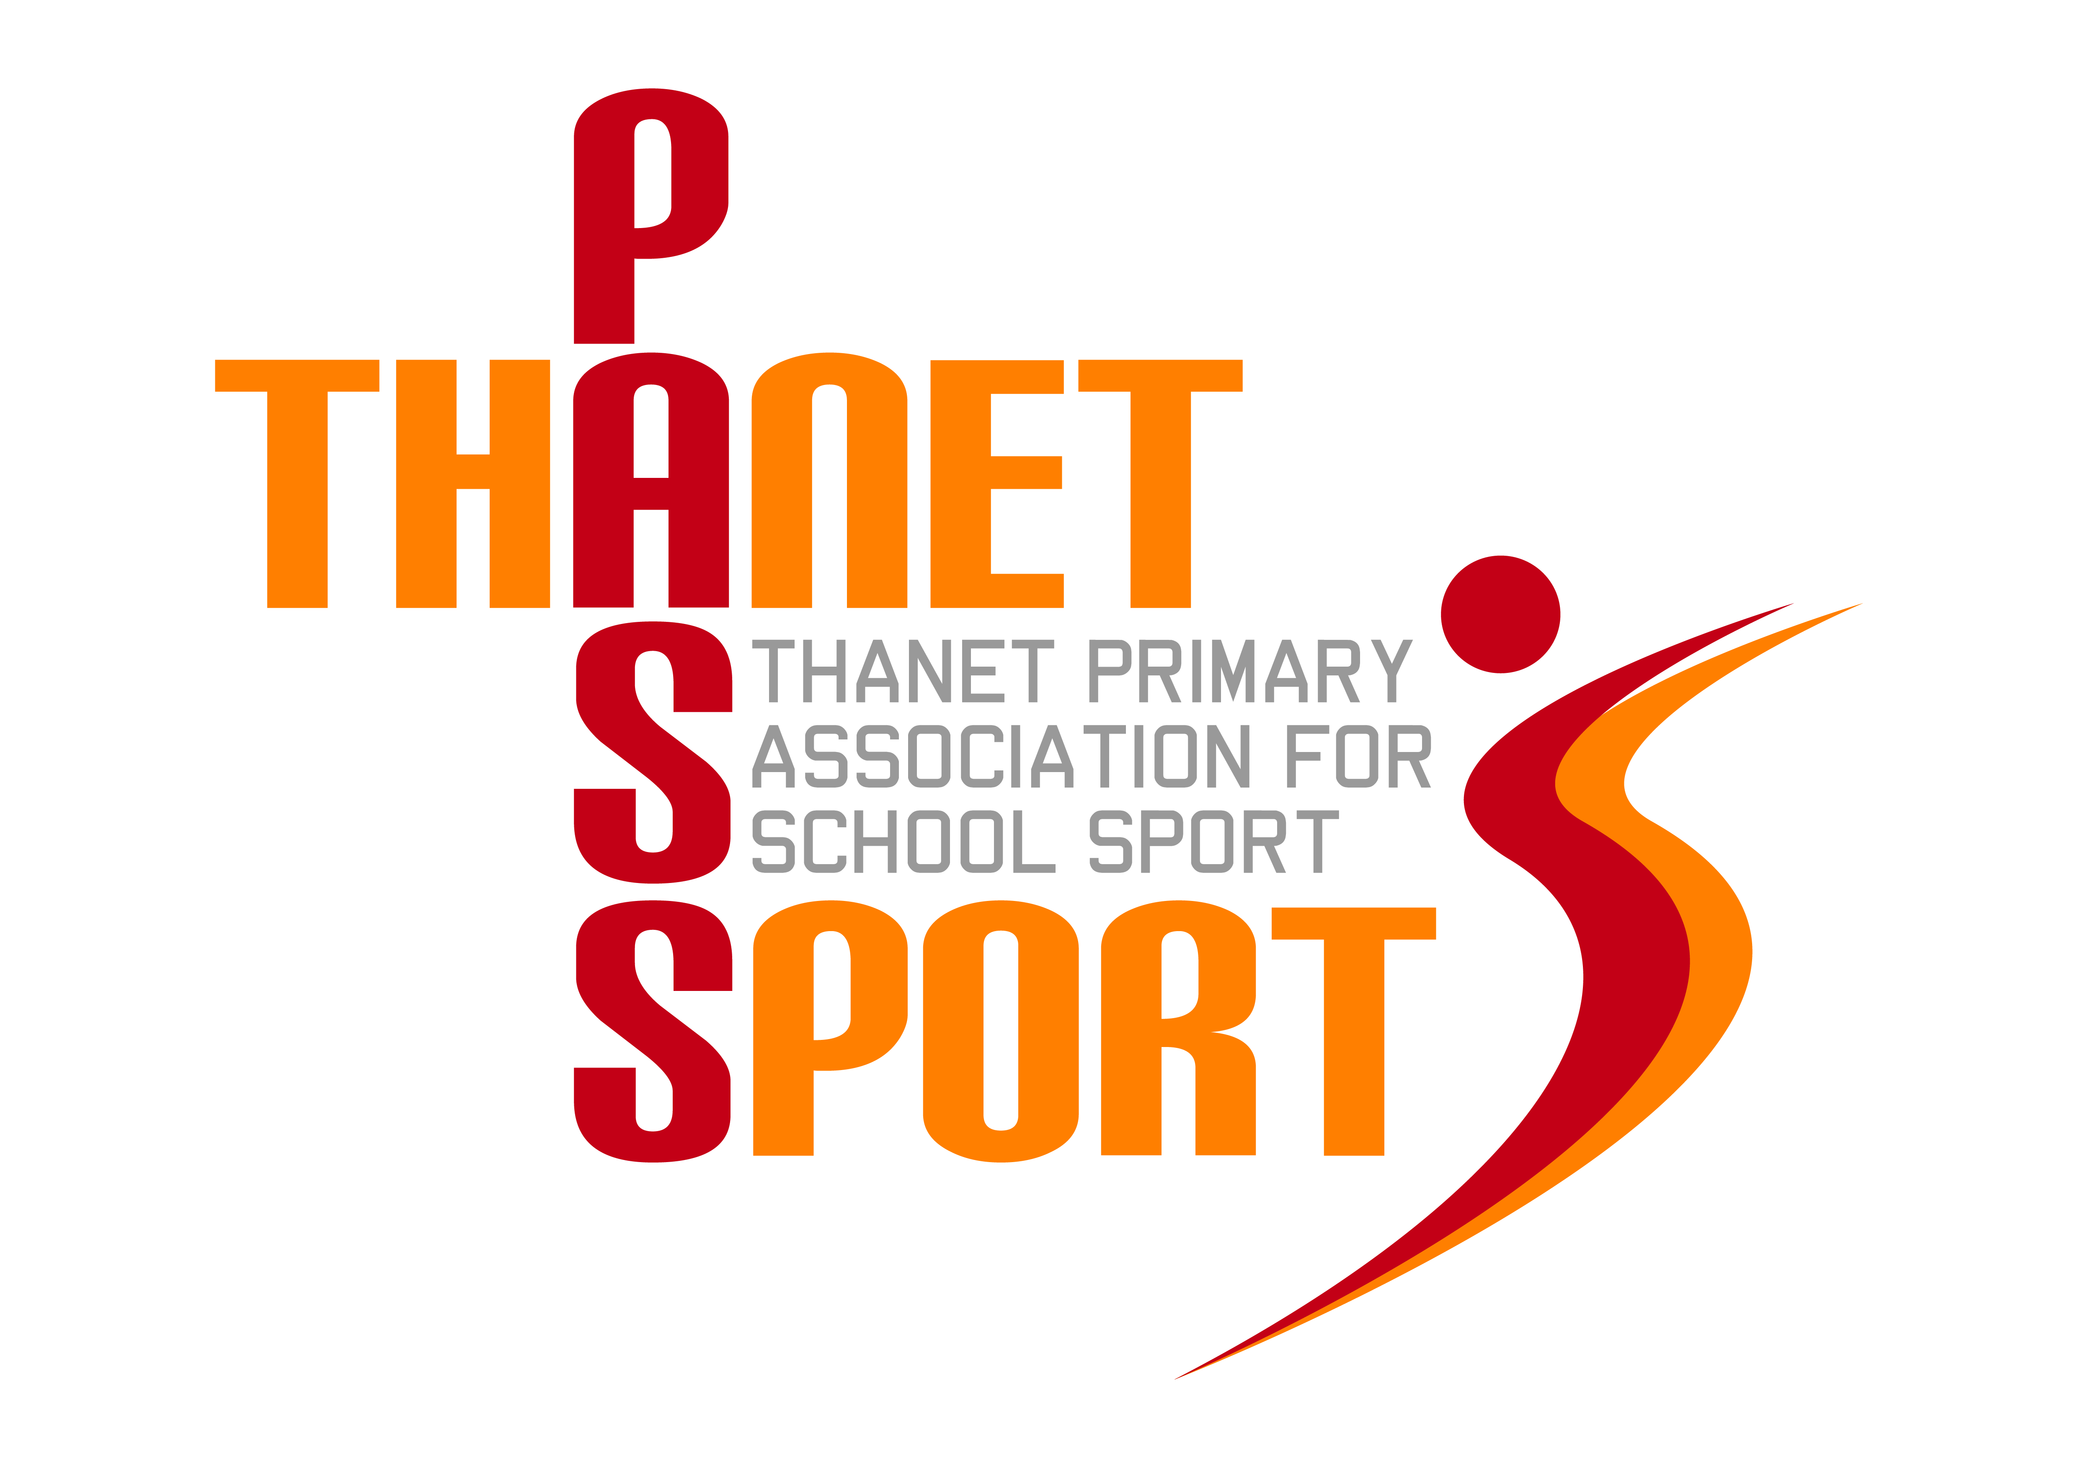
Thanet Primary Association for School Sport

(PasSport)

Annual Report 2017/18
Thanet Passport Committee
Gary Rees (Chairman & Administrator), Lisa Sparkes, Tony Bailey, Sue Mileham, Tracey Jones, Scott Tift, Gwyn Hughes, Steve Holmes
The Year in Review
The highlight of year without a doubt was our Awards Evening at Margate Winter Gardens to celebrate 7 years of our existence. Nearly every primary school in the District was represented and went away with a specially designed engraved glass trophy, which we hope is now proudly on display in all the Passport schools. To get an Olympic and World Champion athlete like John Regis to join us and present the awards was a bit of a coup and he was very impressed with the work that we are doing. We intend to repeat the exercise in the future, probably for our 10th Anniversary in 2021. Sponsorship from ‘Your Leisure’ and Ramsgate Trophies, plus grants from The Gibbons Trust, Thanet District Council and KCC meant that the entire costs of the Awards Evening were covered.

Once again over 4000 primary aged children have taken part in at least one of the 68 events we have helped organise this year. Although we did not quite reach the 10,000 participation figure we were aiming for, we still had 9282 taking part in the 26 sports on offer. This included Boccia for the first time and next year we will be adding Orienteering as well as more opportunities for Key Stage 1 pupils. We were especially pleased this year to offer more opportunities for children with disabilities to take part, which is something we will be seeking to expand in the future.
Despite the demise of ‘Super Passport,’ we were still able to run a few networking meetings for PE staff, which included some CPD and presentations from various sport providers. We hope that more schools will take advantage of this next year, especially as it forms part of the Passport package. Supply costs for release of PE staff to attend these meetings are also eligible expenditure from the Sports Premium.
The affiliation fees for 2018/19 will remain at £600 for Primary and Junior schools; and £200 for Infant and Small schools. This too is eligible expenditure from the School Sports Premium and not only represents extremely good value for money, but it also ticks the box for Ofsted. We have continued to access some sponsorship which has helped pay for such things as First Aid cover from Margate Ambulance Corps, the purchase of hockey equipment and the hire of sports coaches. Some of our sponsorship is ‘in kind,’ such as Braodbiz who maintain our website, Ramsgate Trophies who always donate a large amount of medals, and Margate FC who give us the use of their 5-a-side courts for free. Every school also received 2 polo shirts for the PE staff, courtesy of Total Sports Coaching. Sadly next year we will lose the cash sponsorship from East Kent College, but we are hoping to fill the gap as other local businesses are very interested in supporting us.

Once again several of our schools gained medals at the Kent School Games and our reputation for fair play and sportsmanship is something of which we should all be proud. Enjoyment and participation lie at the heart of what we do and the provision of medals at most of our events remains one of Passport’s hallmarks. However, sport by its very nature is also competitive and many different schools have enjoyed victory in our various competitions. These included:-
Football – Minster, Upton, Birchington, Newington, St Joseph’s, Draper’s Mills, Holy Trinity Ramsgate & St Gregory’s
Speed Stacking – Minster & St Peter’s
Basketball – St Peter’s
Sports Hall Athletics – St Saviour’s & Upton
Dodgeball – St Peter’s
Tri-Golf – Garlinge
Handball – St Joseph’s
Dance – St Saviour’s
Badminton – St Joseph’s
American Football – St Joseph’s & Chilton
Hockey – St Peter’s
Netball – St Joseph’s, Upton, Garlinge & Monkton
Squash – Upton & Garlinge
Infant Agility – Callis Grange
Tennis – St Peter’s & St Joseph’s
Swimming – Upton
Rugby Union – Holy Trinity Ramsgate, St Nicholas-at-Wade, Palm Bay, St Ethelbert’s & Upton
Rugby League – St Saviour’s
Gymnastics – Callis Grange, Bromstone, St Joseph’s & St Mildred’s
Cricket – St Joseph’s & Upton
Quad Kids – Chilton & St Joseph’s
Fair Play – Minster, St Joseph’s, Garlinge, Holy Trinity Ramsgate & Upton

Thanet Passport continues to be very grateful for the continued support of The Ursuline College, providing us with expertise, use of their facilities and administrating our finances. On a personal note I would like to thank Stephanie Selsby, our SGO, and the members of the Passport Committee, plus all of the sports teachers, coaches and event organisers whose commitment and dedication needs to be recognised and commended.
Finally, please feel free to use the Thanet Passport logo on your website or school stationery.
Financial Review
Academic Year 2017/18
Income | £ |  | Expenditure | £
Rollover 16/17 | 4589 |  | Administration | 10737
Schools | 17270 |  | Equipment & Kit | 1570
Grants & Sponsorship | 3125 |  | Coaching & Venues | 1085
 |  |  | Trophies, medals & certificates | 6622
 |  |  | Ambulance & first aid | 800
Total | 24984 |  | Total | 20814
 |  |  | Balance (rollover 18/19) | 4170

Thank you for your continued support as we look forward to an eighth successful year.
Gary Rees
Chairman of Thanet Primary Association for School Sport

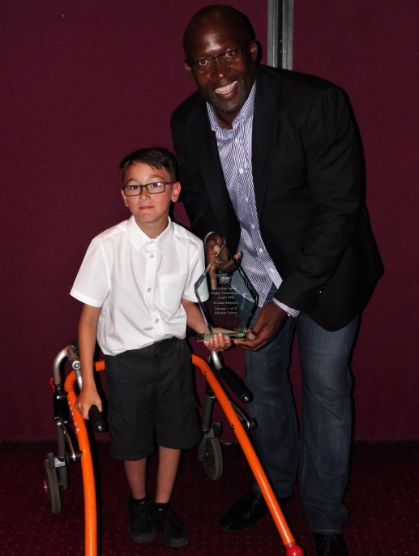
John Regis presenting William with his trophy
at our Sports Awards Evening

