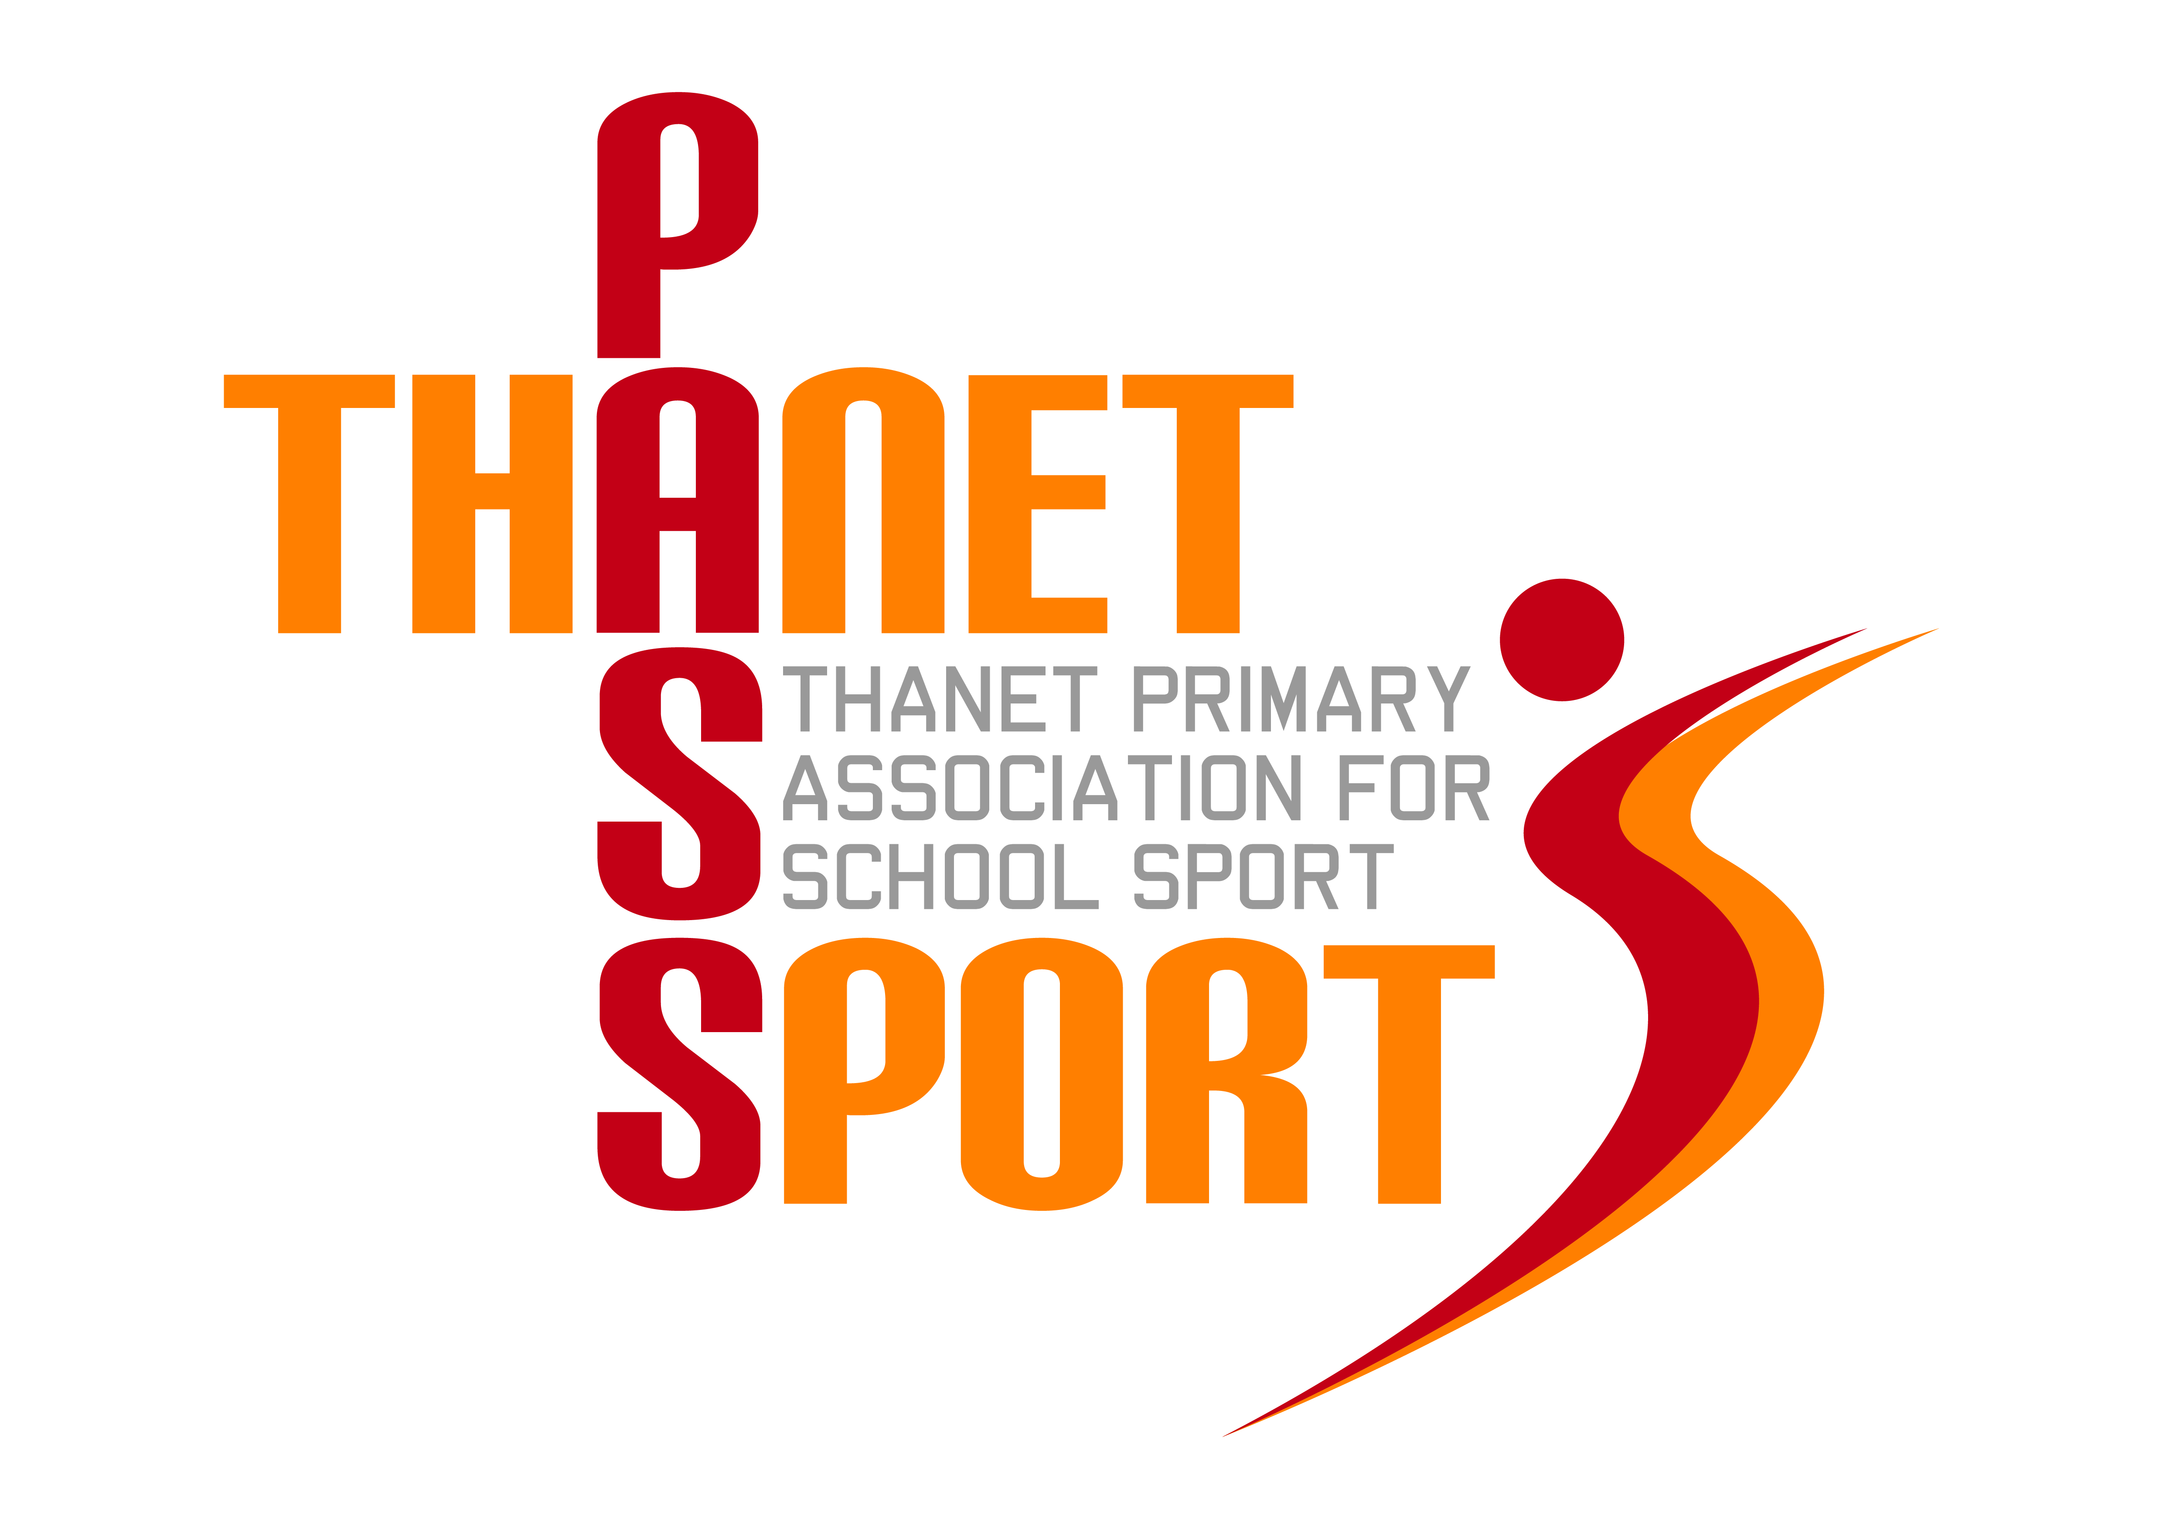
Thanet Schools Kwik Cricket Taster
Date – Friday 3rd May 2024, 4-5.30pm
Venue – Westgate Cricket Club
Open to – Years 3-6 girls and boys
Entries from – 7.30am, Thursday 18th April 2024
Email entries to – garybcrees@gmail.com
Schools are invited to sign up for a Kwik Cricket taster festival. This is an opportunity for players to learn the rules of the game and improve their skills and for staff to take away some ideas for coaching before the Kwik Cricket tournaments.
There are no medals and no trophies on offer.
The event can accommodate up to 8 teams which will be allocated on a first come first served basis. Entries open at 7.30am on Thursday 18th April and close at midnight on Thursday 25th April 2024.
Teams should be made up of a maximum of 10 children. A mixture of boys and girls is advisable, as this is a tournament requirement.
There will be a series of skills stations which each team will visit on a rotation basis.
Parent spectators are permitted at this event.
Further details will be sent out after the closing date.

Thanet Passport – Festival Entry Form
Sport: Kwik Cricket (taster session)
Venue: Westgate Cricket Club
Date & Time: Friday 3rd May 2024, 4-5.30pm
Entry Requirements: Maximum squad size 10
Spectators: Spectators are allowed at this event
Refreshments available: No
School Information:
School:
Team Manager (teacher/coach in charge on the day):
Email address:
Mobile Phone:

*There is a maximum of 8 teams for this event. Places will be allocated on a first come first served basis.

Please return this form to GARY REES, garybcrees@gmail.com no earlier than 7.30am on Thursday 18th April 2024. Closing date for entries is midnight on Thursday 25th April 2024.

