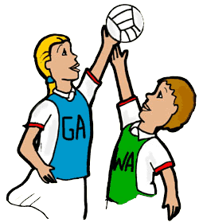

The PASSPORT Netball Cup Tournament - Y5/6
St George’s C of E Foundation Primary School
On Saturday 6th November 2021
9:30am-Noon
7-a-side (squad size is 10) of which there must be no more than 2 boys on court at any one time. There are only 8 spaces, which will be allocated on a first come, first served basis from 7.30am on Thursday 14th October 2021 by emailing:-
garybcrees@gmail.com
Closing date for entries is midnight on Thursday 21st October 2021. Parents are allowed to attend but please inform them that no dogs or smoking are allowed on site.

