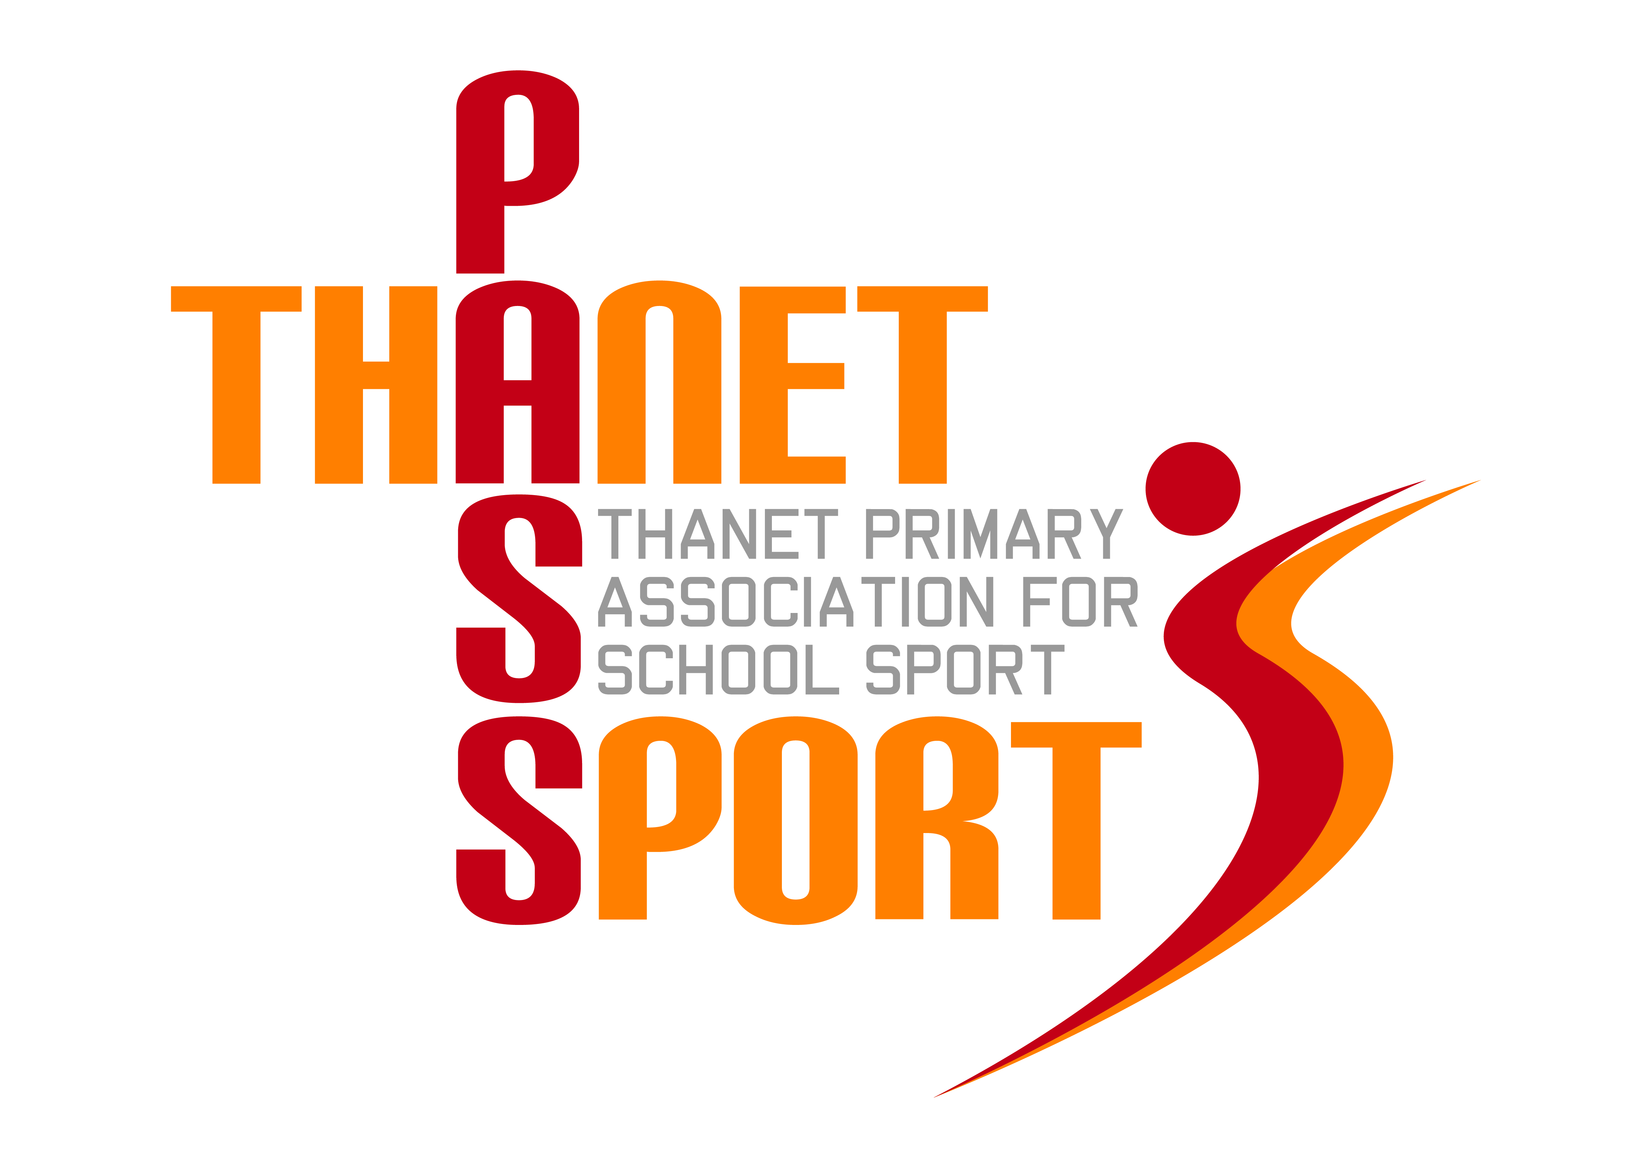Thanet Passport – Competition Entry Form
Sport: Quicksticks Hockey (Tournament) – Year 3/4
Venue: Chatham House Grammar School, Ramsgate
Date & Time: Thursday 24th February 2022, 4-6.00pm
Entry Requirements: 6-a-side. Squads of 8 (4 boys/4 girls).
Spectators allowed: Yes
Restrictions: There must be 3 boys and 3 girls on the pitch at all times and every player must play for at least 2 minutes. It is the responsibility of the teacher in charge of each team to ensure that this rule is adhered to. No goalkeepers.
Shin pads must be worn. Gum shields are advisable. Schools must also bring their own wooden sticks and balls as we do not have spares.
School Information:
School:
Team Manager (teacher/coach in charge on the day):
Email address:
Mobile Phone:

*There is a maximum of 12 teams for this event. Places will be allocated on a first come first served basis.
Please return this form to GARY REES, garybcrees@gmail.com NO EARLIER than 7.30am on Thursday 20th January. Entries close at midnight on Friday 4th February 2022

