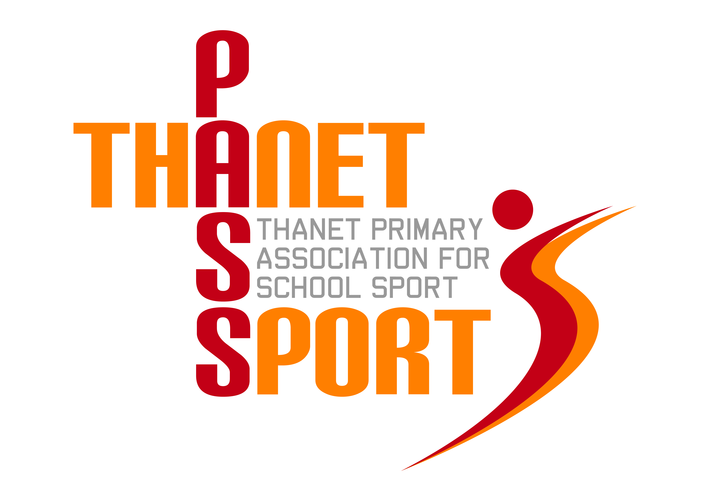Thanet Passport – Competition Entry Form
Sport: Quicksticks Hockey (Tournament) – Year 3/4
Venue: St Lawrence College, Ramsgate
Date & Time: Thursday 18th April 2024, 4-5.30pm
Entry Requirements: 6-a-side. Squads of 9.
Spectators allowed: Yes
Restrictions: There must be a minimum of 2 boys or 2 girls on the pitch at all times but there is no need for timed substitutions. This is a change from previous years.
No goalkeepers.
Shin pads must be worn. Gum shields are advisable. Schools must also bring their own wooden sticks and balls as we do not have spares.
School Information:
School:
Team Manager (teacher/coach in charge on the day):
Email address:
Mobile Phone:

*There is a maximum of 16 teams for this event. Places will be allocated on a first come first served basis.
Please return this form to GARY REES, garybcrees@gmail.com NO EARLIER than 7.30am on Thursday 21st March 2024. Entries close at midnight on Thursday 28th March 2024.

