Tri-GOLF Mixed (Yr. 3/4)
North Foreland Golf Club, Convent Road, Broadstairs, CT10 3PU

When: Wednesday 27th March 2024
Time: 1300 – 1500

This year Thanet’s Tri Golf competition will be held at North Foreland Golf Club. We are delighted to be working in partnership with the club and offering an enriched experience to the children attending.
The format will be adapted to include a traditional golf lesson experience as well as completing Tri Golf activities.

Team information
A maximum of 10 teams can enter this competition; schools will be accepted on a first come first serve basis.
10 in a team (ideally 5 girls/ 5 boys but no stipulation).

Timings
1245 – Schools to Arrive at North Foreland Golf Club. Minibuses should be parked on the grass adjacent to the main visitors parking. If you are not arriving in school transport, please meet your team outside the main entrance of the Club House (signposted from the visitors car park). Registration will take place here also.
1300 – Teams will begin their first activity as per the schedule (this will be available after the closing date for entry. Teams will have approx. 10mins at each activity, this will include 2mins practice, 5mins recorded play, briefing from the leaders and moving time from each activity.
1500 – Teams will complete their final activity.

Competition Format

All teams will complete a carousel of 4 different Tri Golf activities. The children will be judged on their ability as well as their ‘Skills for Life’. They will also take part in multiple Golf practices with a Golf Pro from the club in their range area of the course.

Tri Golf year 3/4 2024 – Team Entry

School Name
Contact Name
Contact Telephone
Email
Do you have the capacity to field a B team should there be space? | YES / NO

Please check this box to confirm that you have read and understood the Thanet Passport Code of Conduct for School Sport.

To enter please complete the entry form and return by email NO EARLIER than 7.30am on Friday 23rd February 2024 to:

sgo@ursuline.kent.sch.uk
Closing Date for entries is midday on Friday 1st March 2024.
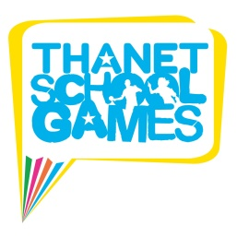
Any entries received after the deadline will not be accepted.

